**Gatsby Benchmarks**

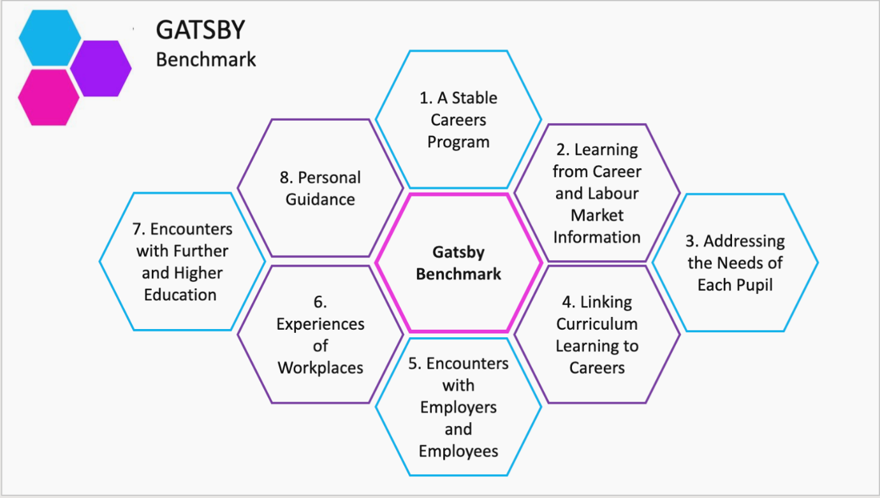

|  |  |  |
| --- | --- | --- |
| **Gatsby Benchmark** | **Strategy** | **Additional Information** |
| **A stable careers programme** | Woodlands has a stable and well-structured career plan and an identified person responsible for it. |  |
| **Learning from career and labour market information** | Woodlands ensures that by the age of 14, all pupils have accessed information about career paths and labour market to inform their own decisions on study options.  The Woodlands weekly Parent Information letter informs on Careers across the curriculum. | <https://nationalcareersservice.direct.gov.uk/> 0800 100 900  [essex.careers.magazine@essex.gov.uk](mailto:essex.careers.magazine@essex.gov.uk) |
| **Addressing the needs of each pupil** | Woodlands careers program is tailored to the individual needs of our pupils. Woodlands takes positive steps to ensure our careers program is inclusive for all pupils from all backgrounds including those with SEND, and that they can consider the widest range or careers.  Woodlands works with partners (Directions and Department for Work and Pensions) to provide targeted support to pupils with vulnerabilities and additional needs. | Comprehensive records are kept to support the careers and enterprise development of pupils.  Woodlands collects and analyses post-16 destination data, with a particular view to measuring success in raising aspirations.  Woodlands is developing an alumni network of pupils that have recently left who share experiences of Post-16 and Post-18. |
| **Linking curriculum learning to careers** | Career development is supported through subject teaching and careers within the curriculum.  Careers, employability and enterprise lessons are delivered through the AROE program. | Our Weekly Newsletter to parents has a Careers across the Curriculum update. These are supported by teaching staff from each department/faculty. |
| **Encounters with employers and employees** | Woodlands careers program helps pupils gain the confidence to compete in the labour market by providing opportunities to gain the practical and know-how and attributes that are relevant to employers. This includes the development of soft skills.  The Work Experience program in Year 10 offers pupils the opportunity to work with employers and develop these skills. | Engagement with employers may include:   * Post-16 careers event; * Employer encounters through work experience; * Armed forces workshops; * National Careers Challenge; * Visits to Ikea for example; * Employer talks; * Mock interviews; * CV writing workshops; * Trips and visit opportunities; * STEM workshops. |
| **Experience of workplaces** | Woodlands careers program supports high quality work experience.  By the age of 15, every pupil has, at least one experience of a workplace. | Work Experience may include:   * Trips and visits; * One week work experience (July Year 10); * Workplace visits; * Work experience in school. |
| **Encounters with Further and Higher Education** | Woodlands supports pupils in their preparation for Post-16 and the requirements to remain in education and or work-based training until they are 18. | This requirement can be met through:   * Full-time study in a school, college or training provider; * An apprenticeship. |
| **Personal guidance** | Woodlands provides personal guidance interviews with a qualified Careers Advisor;   * By the age of 16, every pupil has had at least one interview.   Pupils with vulnerabilities or additional needs have additional support. | Directions careers service offer pupils’ personal guidance interviews.  Department for Work and Pensions provide additional support to pupils with vulnerabilities or additional needs. |